GEL
FILTRATION
CHROMATOGRAPHY

ARYA BASAK
23MS233

AIM: To determine Column Void Volume using Gel Filtration Chromatography

MATERIALS REQUIRED:
Chromatography column, Sephadex G-25, Buffer, Blue dextran, collection tubes, clamp stand.

THEORY:
Molecules of different compounds can be separated on the basis of their size, shape and charge by various separation methods. The maximum number of compounds that can be separated in a single analysis of the various separation methods is very different for different molecular masses of the analyte.

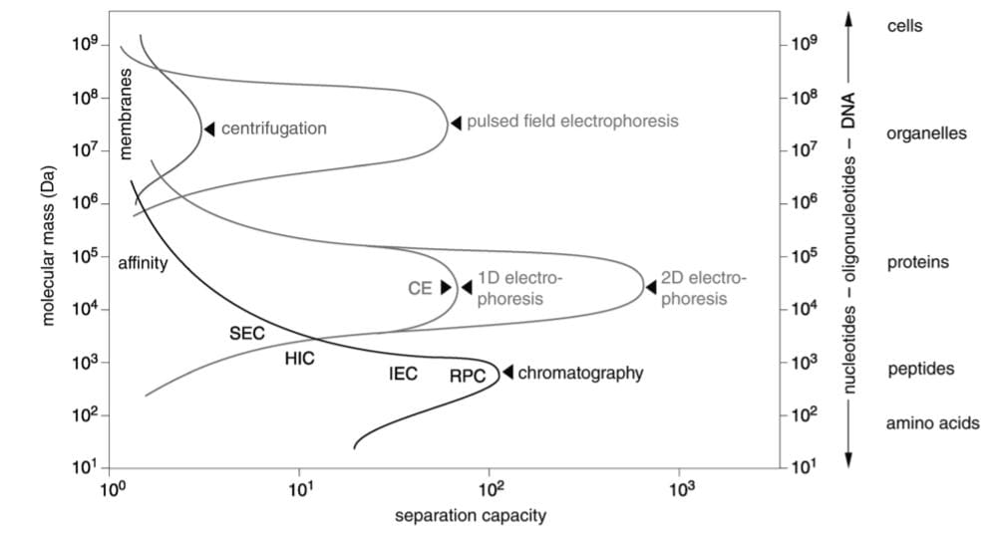
Separation methods for Proteins and Peptides

Some of the separation techniques include Centrifugation, Electrophoresis and Chromatography.

Chromatography
A scientific technique that separates a mixture of chemical components by passing it through a stationary phase and a mobile phase.
Stationary phase is a solid or liquid phase that remains fixed in place.
Mobile phase carries the mixture through stationary phase.

What is Gel Filtration Chromatography?
Gel Filtration is a technique that separates molecules on the basis of size (and shape). Gel Filtration Chromatography is a form of partition chromatography which is used for this separation. It is also known as Molecular sieve chromatography, Gel permeation chromatography and Size exclusion chromatography.

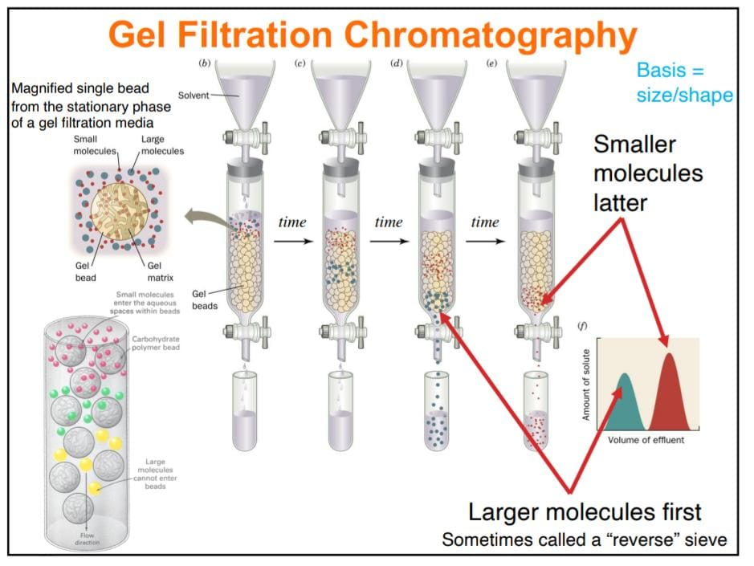

In Gel Filtration Chromatography,
- Stationary Phase – Beads made up of pores that span a relatively narrow size range in a long cylindrical column. It is expensive and challenging to control pore size of beads.
- Beads are the packing material, the gels. They are cross linked polymers used as molecular sieves and are inert. Three types of gels are used – Dextran (Sephadex), Polyacrylamide, Agarose.
- We will use experiment Sephadex G-25 in our experiment and it will separate molecules with molecular weights from 3,000 to 70,000. Molecules with molecular weights larger than 70,000 will be excluded from the beads. Blue Dextran is to measure the column void volume.

- Mobile Phase – Buffer (NaCl)
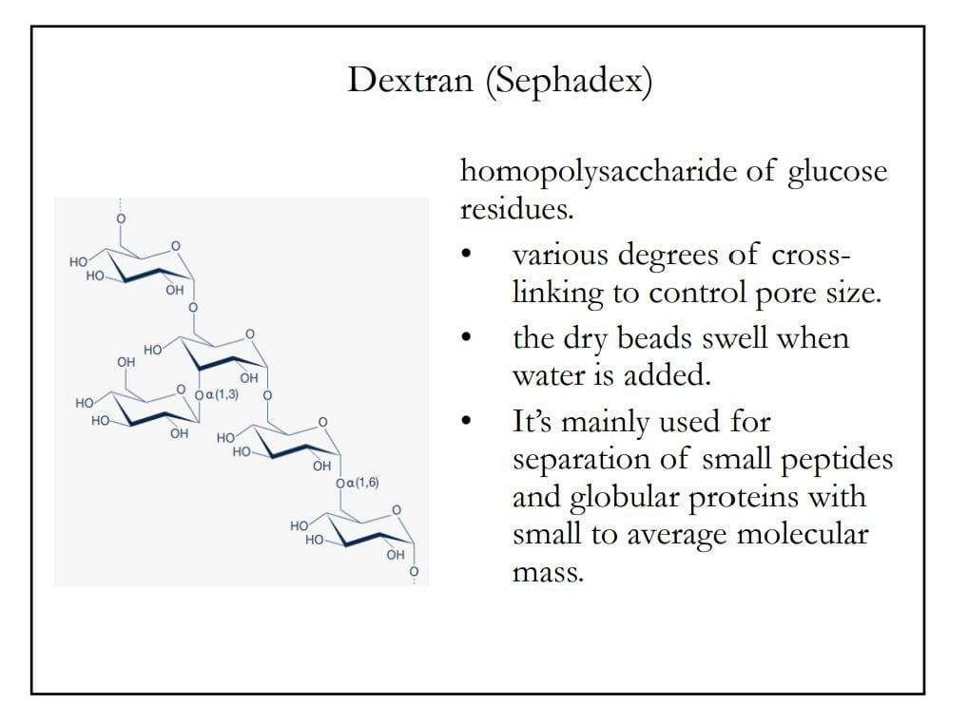

PRINCIPLE:
The beads used as packing materials are porous. Their pores are large enough to accommodate smaller size molecules. When the analyte is poured in the column, the smaller molecules spend more time inside the beads than larger molecules since the former one get trapped in the pores. Therefore, the small molecules elute later after a larger volume of mobile phase has passed through the column. In this way, molecules get separated based on their sizes.
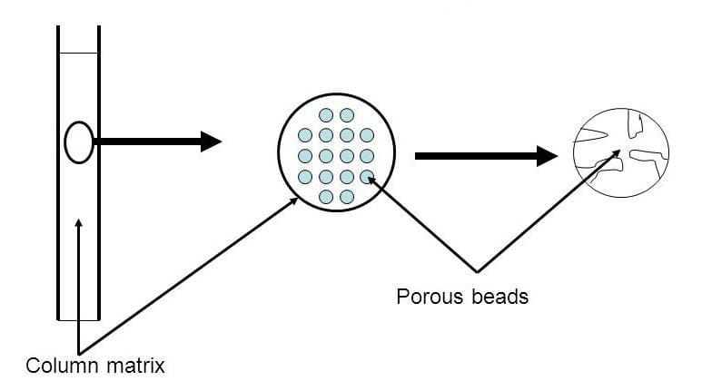

Large Molecules are “excluded” from the pores and travel through the column fastest.
Small molecules are “included” and can diffuse into the pores and elute later.
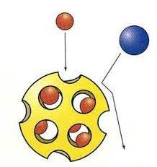
Column Parameters:
V₀ = Void Volume, also known as dead volume is the volume of a column in chromatography that is occupied by mobile phase and not by packing material.
V_{t} = Total Volume of a chromatography column, also known as column volume or bed volume is the sum of the void volume and inner volume.
V_{s} = Volume of solvent held in the pores.
V_{e} = Elution Volume is the volume of mobile phase that must pass through a chromatographic column after sample application, to produce a peak in the concentration of a particular solute in the effluent (Volume of solvent between injection and elution).

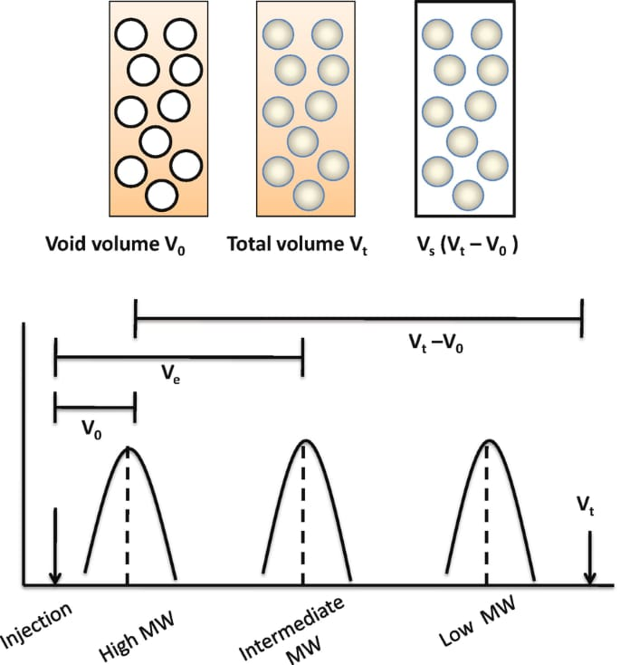

For heavier molecules, they will get totally excluded by the beads. So, they come out faster when the effluent volume is lower. In this case, the effluent volume gives the void volume. As time progresses, the effluent volume continues to increase and the molecules with subsequent lower molecular weight comes out. As a result, the chromatogram for a mixture of components looks like this.

Elution Volume is dictated by proportion of porous matrix available to molecules (Kd).
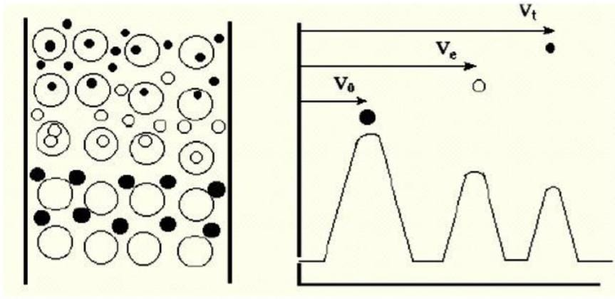
Elution Profile: Three cases

Behaviour of molecule on any Column
K_{d} = [B]_{stationary phase}/[B]_{mobile phase}
Kd is the ratio of the concentrations of the component in the stationary and the mobile phases.
Let the flow of component B through the column is retarded and it elutes at Ve(B). (Ve(B) – V0) is the extra stationary phase volume, which is a component of the internal pore volume Vi and the partition coefficient of B can be expressed as a fraction of Vi.
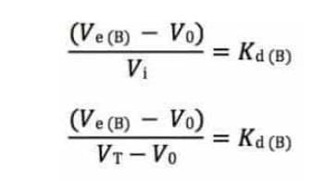
V_{T} is the total solvent accessible volume, a parameter which is difficult to measure. So, we can substitute V_{T} by V_{C}, the total geometric volume of the column.
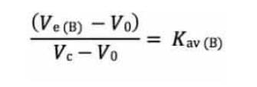

Kav is not a true partition coefficient but is easily determined.
Kav = proportion of pores available to the molecule.
Totally “exclude” Kav = 0 and Ve = V0
Totally “included” Kav = 1 and Ve = Vt

PROCEDURE:
- The column with the gel packed inside is clamped to the stand.
- We have taken 10 mg/ml Blue Dextran in 50mM Tris-HCl, pH=7 and 100mM NaCl buffer.
- Then the total content of the Blue Dextran is mixed.
- Volume of the dextran is 2% of the bed volume = 990 ul (Bed Volume measured = 49.5 ml)
- The buffer is then drained out until it reaches the top of the gel. DO NOT LET THE COLUMN RUN DRY.
- Using a pipette, we slowly add blue dextran sample to the top of the gel with stopcock closed. The gel must not be disturbed.
- A collection tube is placed under the stopcock. We open the stopcock and allow the sample to move onto the column and then close it.
- We slowly add 1 mL of buffer to the top of the column (at its centre) and drain into the collection tube. Around 10 mL of buffer is added to the top of the column and drained.
- The collection of buffer continued until the first appearance of blue colour is seen to elute from the column. This total volume of collected buffer is recorded and it should be colourless.
- All the blue dextran is then collected in 1 ml tubes. In each tube, 500ul of blue colour elute is taken consecutively. The buffer is continuously added to prevent the column from running dry.
- After all the blue dextran is past, we closed the stopcock.
- Then we added 500ul of buffer into all the 1.5 ml tubes, mix well and take the absorbance at 610 nm wavelength using plastic cuvette. This buffer was added, so that Absorbance (OD) remains within 1 (Lambert-Beer’s range). We noted down the tube number showing the maximum absorbance.
- The total volume obtained in the previous step gives the void volume.

OBSERVATION:

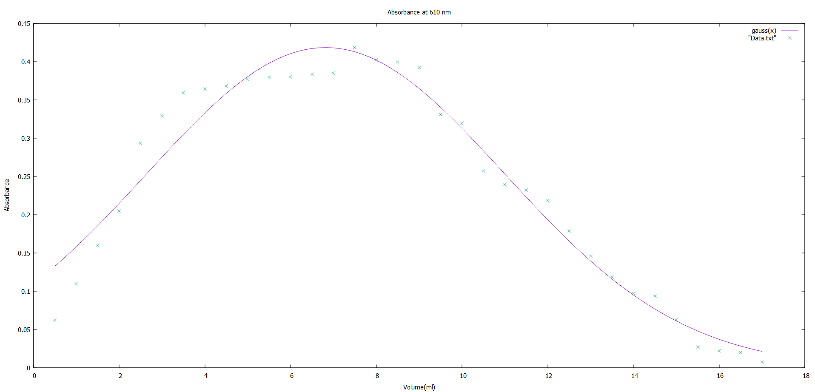

CALCULATION:
The Tube number with maximum absorbance is 15.
So, the effluent volume = 7.5 mL
Collected Buffer = 16 mL
Void Volume of the column = (16 + 7.5) mL = 23.5 mL

CONCLUSION:
So, Blue Dextran is used as a void marker since it is a large molecule and gets totally excluded by the beads. Its Elution Volume gives the measure of void volume directly.
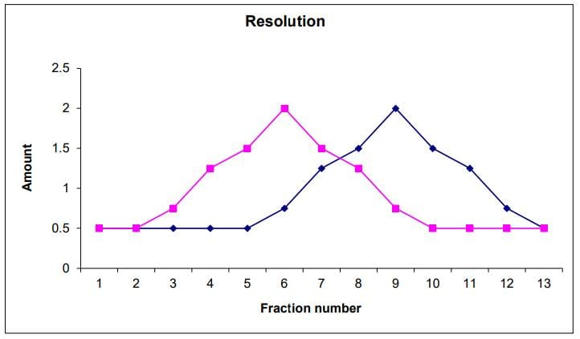
We can conclude that slow rates allow efficient partitioning into pores and thus increase Resolution. However, slow rates increase diffusion of sample on column, thus increasing peak width, reducing Resolution.
Resolution is proportional to square root of column length.
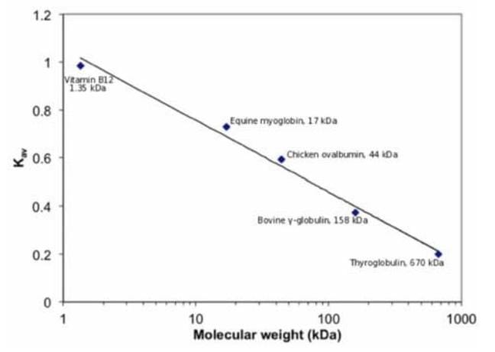
Determination of molecular weight is also possible by calibrating the column with known standards. We can plot Kav against log (Molecular Weight)

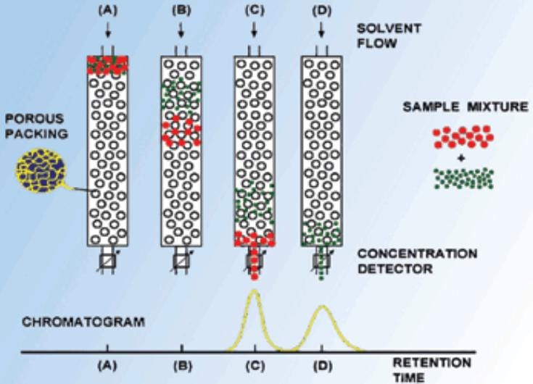

We can also use Retention Time instead of Volume as a column parameter for the separation of molecules.

